Topic: Renewable Energy
Student Version

Summary:

You will learn more about the development of renewable energy in our country and the importance of energy conservation through the following activities:

- Viewing the video “Bringing Energy to People Who Need It Most” about the building of an energy supergrid in China to learn about our country’s efforts in sustainable energy development

- Reading an article “Biomass Technology Shows Huge Growth” to explore the development of biomass technology in China and learn to work out the meaning of unfamiliar words/phrases using contextual clues

- Writing a checklist to suggest effective ways to save energy in daily life

- Researching information about the latest infrastructure on renewable energy in our country and a food waste recycling project in Hong Kong to help safeguard resource security

Part 1 – Pre-viewing
- Introduction
Resource security is the lifeblood of national strategy and the backbone of national development. It includes the development, utilisation and sustainable supply of both renewable and non-renewable resources such as water resources, energy resources, land resources and mineral resources. Electricity, as one of the most common energy sources, plays a pivotal role in our daily lives. Find out more about China’s committed work in balancing the national production and consumption of electricity.

- Discussion
- Energy is all around us in nature. Some sources of energy will never run out while some are limited and will be exhausted over time. How much do you know about renewable and non-renewable energy? Write down some examples in the diagram below.
Non-Renewable Energy

Renewable Energy

- What problems would arise if there was no electricity in the world? How would people’s lives be affected?

- Daily Life | - Economy | - Safety

- How does energy shortage affect the stability of a country?

_____________________________________________________________________

Part 2 – Video Viewing
- Watch the video “Bringing Energy to People Who Need It Most” and complete the diagram below.
https://chinacurrent.com/story/24115/chinas-building-a-supergrid

The “West-East Power Transmission and North to South Power Supply” Project

- It aims to (k) ________________ to the areas with high demand
- (l) A _____________ has been built in north-west of China to transport the surplus electricity from the West to the East through the transmission lines.
- Electricity supply is closely tied to a country’s (c) ___________ development and different aspects of people’s livelihood, e.g. water supplies, (d) _________, (e) _____________ and financial services.
Central and Eastern provinces in China
- More than (i) ____ of energy consumption and resources
- Electricity is vital to basic, human needs, e.g. access to clean water, (a) ___________
______ and (b) ___________.
North-west of China
- More than (h) _____ of energy production and resources
- (f) ______________ will affect the security of people and (g) __________________.
- The pressing problem
(j)___________________________________________________________
- What other infrastructures have been built in our country to generate electricity for powering the megacities?
Source: https://chinacurrent.com/story/20749/24-hours-of-sun
(a) | (b)

- According to the video, which of the following helps alleviate energy poverty in some regions in China?
Rehousing the population from the densely populated regions
Attracting more foreign investment in building energy infrastructure
Innovation in energy technology and power distribution

- The power transmission project benefits the citizens in the densely populated regions. What should the citizens in these regions do to be responsible energy users?

- What can be done to raise people’s awareness of energy conservation issues?
- The Government: ______________________________________________
- The enterprises: _______________________________________________
- Schools: _____________________________________________________
- Individual citizens: _____________________________________________

Part 3 – Post-viewing
- Reading

- You are going to read an article about the development of biomass technology in China.

- Study the word “Biomass” in the title of the article. What do you think is involved in this technology?

- Explain your answer.

- The picture below shows the type of biomass used in Mengcheng county, Anhui province to generate power.

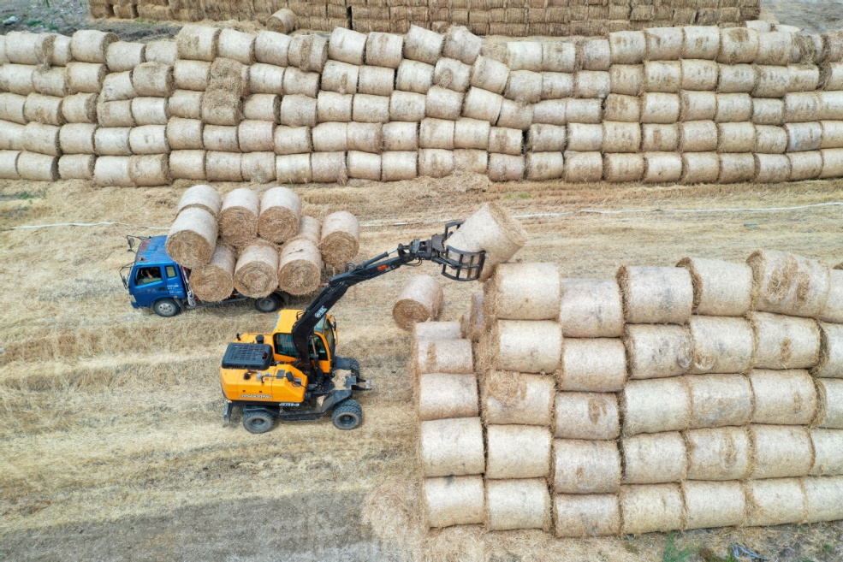
What kind of biomass is it?

- Can you think of other examples of biomass?

- Read the article and answer the questions.

Biomass Technology Shows Huge Growth
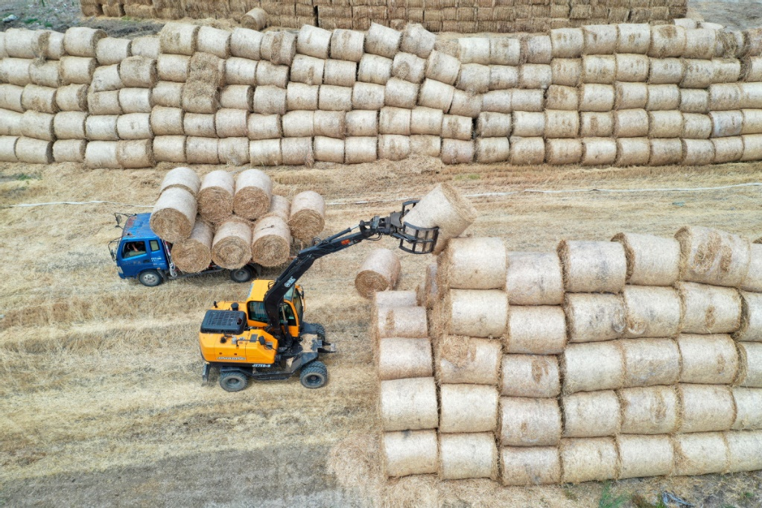

5  10  15  20  25  30  35  40  45  50  55  60 | Organic waste, including wood, crop byproducts and animal droppings, may soon play an important role in facilitating global carbon neutrality as energy sources to heat homes and fuel cars.  In Heilongjiang province, State Power Investment Corp has been working on a technology to compress corn straw, residues and agricultural and associated processing wastes into fuel to provide clean heating to local residents.  The technology will be put into use by 2024 and replace coal to provide clean heating for more than 10 million square meters in Jiamusi, Heilongjiang, the company said.  As the country’s first domestic biomass green energy particle technology, it will make better use of the availability of large quantities of corn straw and other residues, breaking the bottleneck of inconvenient transportation and storage for biomass energy utilisation, said Ma Mingjun, General Manager of Shanghai Power Equipment Research Institute Co Ltd.  Biomass, such as agricultural and forestry products, organic household waste as well as livestock and industrial refuse, refers to some of the biological materials used as fuels in producing electricity and heat. It can be burned directly for heat or converted to renewable fuels through thermal, chemical and biochemical processes.  Under the energy efficiency and carbon intensity targets set by the Chinese government, the country’s development of biomass energy is likely to be fast-tracked thanks to preferential policy support, experts said.  China’s development of the biomass energy industry is set to embrace major opportunities under China’s strong green commitment, according to Zhang Dayong, secretary-general of China’s Biomass Energy Industry Promotion Association.  The industry has great potential for further growth as China strives to achieve carbon peak by 2030 and carbon neutrality by 2060, he said.  China produces over 900 million metric tons of agricultural and forestry biomass every year, which can generate power equal to nearly 400 million tons of coal. The number is even larger including other organic waste from urban and rural areas, according to the association.  However, at present, only 90 million tons of agricultural and forestry biomass is used for power generation annually. The high costs of collecting raw materials and relatively low power generation rates compared with coal and other mainstream energy sources have been hindering the industry’s development, officials said.  State Power Investment Corp’s attempt to compress corn straw, understory residues and agricultural and related processing wastes into fuel, however, is expected to represent a breakthrough for biomass heating in the country, said Luo Zuoxian, head of intelligence and research at the Sinopec Economics and Development Research Institute.  The country’s 14th Five-Year Plan (2021-25) has sent positive signals encouraging biomass energy, he said.  The country’s installed capacity for biomass energy rose to 37.98 million kilowatts by the end of last year, while the annual power generation capacity for biomass also rose to 163.7 billion kilowatt-hours during the same period, according to the National Energy Administration.  Last year, China’s installed capacity of biomass power generation connected to the grid increased by 8.08 million kW, a record high that also ranks first in such field in the world, it said.  The administration has called for support from local governments for biomass energy projects, with heating being a priority.  China’s strong green commitment will provide more opportunities for the growth of biomass energy development as biomass is a net zero-carbon fuel compared with other renewable energy sources, Zhang said.  While burning biomass releases carbon dioxide, the plants that make up biomass capture almost the same amount of carbon dioxide while growing, experts said.  According to a report released by the association, the government is expected to provide more support to boost the industry’s development in the next five years. An estimated 1.2 trillion yuan ($172.32 billion) is to be invested in the industry from 2021 to 2025. That is expected to help the industry handle about 350 million tons of organic waste and create job opportunities for around 1 million people, the report said.  By 2030, the proportion of biomass energy in renewable energy is forecast to increase to about 8 percent, it said.  The government is also working on the combination of biomass heating with carbon capture and storage. It will extract energy from biomass, capture and store the carbon and turn biomass into energy to achieve negative emissions, the association said.
Source: http://global.chinadaily.com.cn/a/202212/15/WS639a8b61a31057c47eba48e5.html

- Write down three examples of organic waste used for producing biomass energy in China.

- Which of the following challenges are faced by the biomass energy industry in China?
(A) Difficulty in transporting biomass
(B) Limited supply of corn straw
(C) Storage of biomass
(D) Lack of government support

- Complete the diagram below using information from the text.

How Does Biomass Energy Work?
(iii) Generating ____________ for homes and utilities.

(Image: https://www.emsd.gov.hk/filemanager/en/content_61/Book_2_RenewableEnergy.pdf)

- Using organic waste such as ______________________________________________________________________________________ as fuels to generate electricity
(ii) ________ the biomass directly or converting it to renewable fuels through _______________ _____________ and _____________ processes.

- According to paragraph 6, experts hold a/an ______________ view on the development of biomass energy in China.
(A) neutral
(B) optimistic
(C) pessimistic
(D) uncertain

- Find a word in lines 34-38 which means “an important discovery or event that helps to improve a situation or provide an answer to a problem”.

- Read paragraphs 8-10 again. Decide if the information in the following statements is “True”, “False” or “Not Given”.

 | Please tick () the appropriate box.
 | True | False | Not Given
- The development of biomass energy industry will help China achieve carbon neutrality.
- The Chinese government purchased agricultural and forestry biomass from the farmers for energy production.
- More coal is needed than biomass to produce the same amount of energy.
- The biomass in China has not been fully utilised for generating power.
- It is expensive to collect biomass in China.

- Discuss with a partner and write down three benefits of using biomass energy.

- Apart from supporting the use of renewable energy, what else can we do to help safeguard resource security?

- Language Focus
Working out the meaning of unfamilar words/phrases using contextual clues

“Look around the word/phrase” is a useful strategy for working out the meaning of an unfamilar word/phrase. Stop and reread the words that come before and after the unfamiliar word/phrase will provide you with clues to work out the meaning.

Example
What is the meaning of the word “hindering” (line 33)?
- Making something possible or easier
- Limiting the ability of someone to do something or the development of something
- Showing improvement within a short period of time

“High costs” and “low power generation rates” are related to the problems of biomass energy.
The word “only” suggests that the use of biomass for power generation is not desirable.

However, at present, only 90 million tons of agricultural and forestry biomass is used for power generation annually. The high costs of collecting raw materials and relatively low power generation rates compared with coal and other mainstream energy sources have been hindering the industry's development, officials said.

The word “hinder” modifies the noun “development”. As the clues about the use of biomass energy are related to some undesirable situations and problems, the word “hinder” bears a negative meaning.

Practice
- What is the meaning of the word “fast-tracked” (line 19)? Circle the contextual clues and explain your answers.

Under the energy efficiency and carbon intensity targets set by the Chinese government, the country’s development of biomass energy is likely to be fast-tracked thanks to preferential policy support, experts said.

- Monitored in the near future
- Made to stay in a place or situation
- Increased at a quicker than normal route or level

- What is the meaning of the word “boost” (line 56)? Circle the contextual clues and explain your answers.

According to a report released by the association, the government is expected to provide more support to boost the industry's development in the next five years. An estimated 1.2 trillion yuan ($172.32 billion) is to be invested in the industry from 2021 to 2025. That is expected to help the industry handle about 350 million tons of organic waste and create job opportunities for around 1 million people, the report said.

- To improve or increase something
- To delay and reduce the scale of something
- To convince people to believe in something

Part 4 – Writing
To help raise your schoolmates’ awareness of energy conservation, you have decided to prepare a checklist on ways to save energy in daily life. Research online and interview your teachers, friends and family for suggestions. Choose the best three suggestions and complete the checklist below.

Things to Do to Save Energy

At School

At Home

In the Community

